**Microsoft Northwind Data Warehouse Project** 🚄🗎  
A Data Warehouse initiative developed using the Microsoft Northwind Database.

**Star Schema for Data Warehouse:**  
*Diagram included*

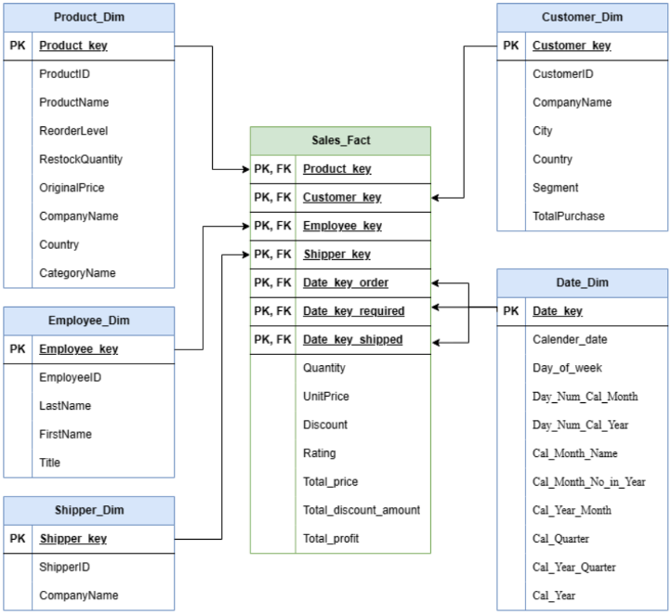

**Business Intelligence Reports:**

* **Report 1: Market Basket Insights**  
  Leverages Common Table Expressions (CTEs) and the "WITH" clause for streamlined queries, along with the "CUBE" function for summarized analytics. Users can specify time periods, regions, and product categories (or include all).  
  **Uses:** (1) Identifying cross-selling opportunities and (2) optimizing inventory control.

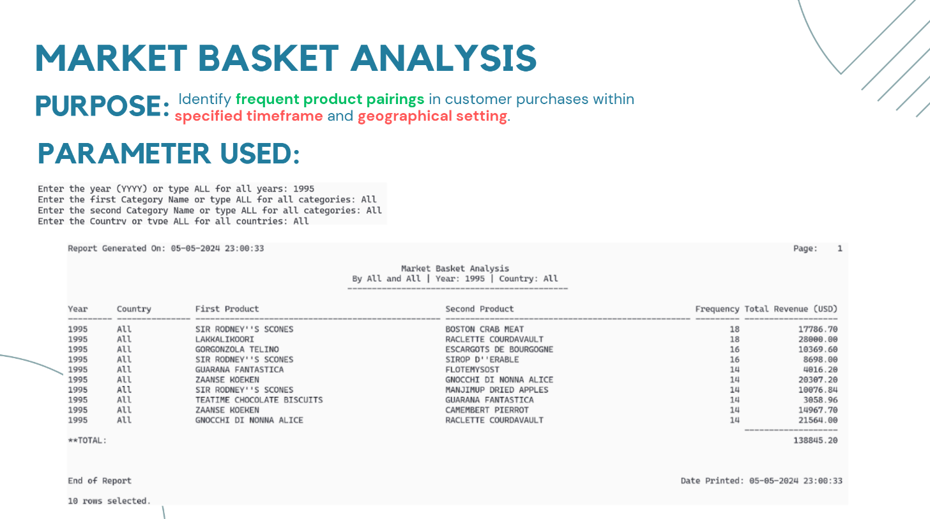

* **Report 2: Market Reach Analysis**  
  Combines CTEs with the "ROLLUP" function for both granular and summarized views of market performance. Customizable for specific periods, regions, and product ranges.  
  **Uses:** (1) Strategic marketing and (2) effective resource distribution.

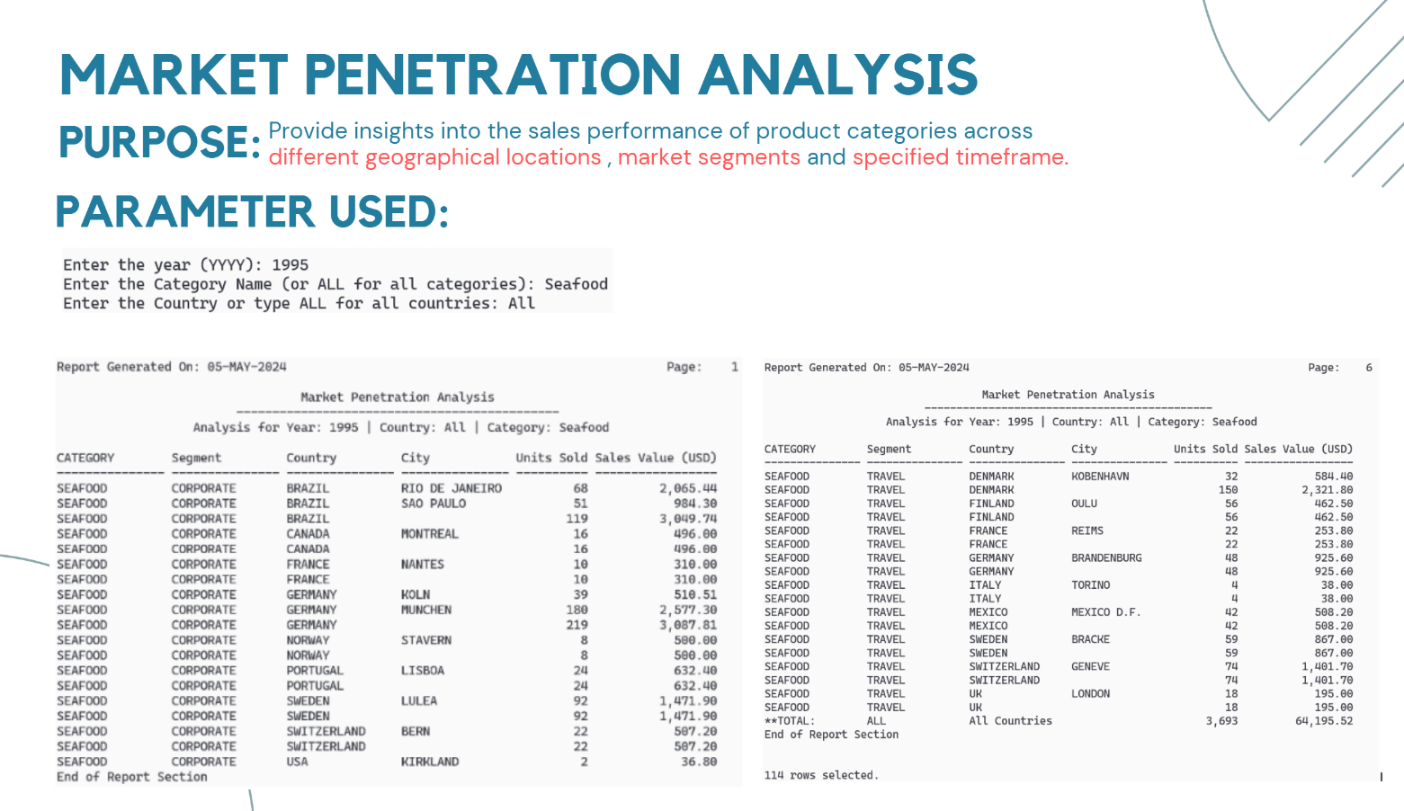

* **Report 3: Customer Satisfaction Insights**  
  CTEs and "ROLLUP" functions provide detailed to high-level views of customer satisfaction by segment. Users can select a particular year and country for targeted analysis.  
  **Uses:** (1) Customer retention and churn prevention, and (2) personalized marketing strategies.

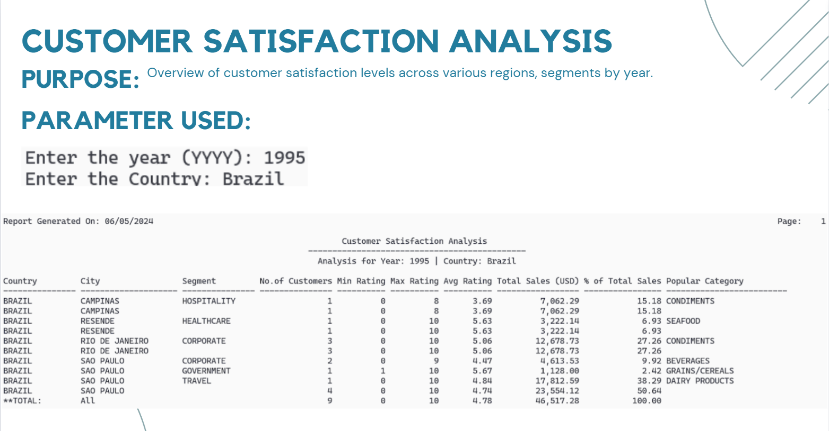

Images included where relevant for visualization.